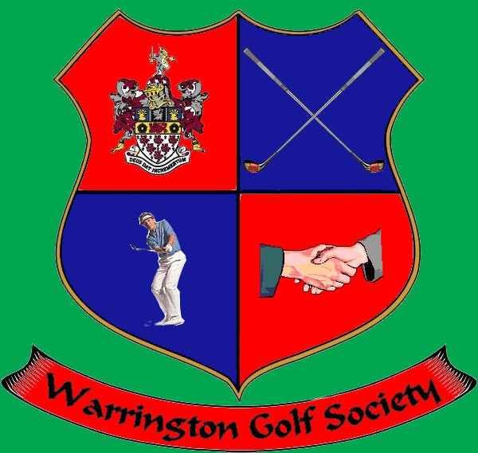
Membership Information
Tired of paying extortionate Golf Club membership fees!!!!!!
Membership for The Warrington Golf Society is available at any time of the season.
Subscription is currently £20. Dress code is currently Society Polo shirt on course, White embroidered short sleeved shirt with blue tie and black pants in the Clubhouse at the major events.
Games are played throughout the Northwest every three weeks from February through to October. There are bacon or sausage barms for breakfast followed by golf at 10:00. At each of the five major meetings there will be a two or three course evening meal.
Prizes on the day are awarded for nearest the pin on all par threes, nearest pin in two for high and low handicap, £20 to winner. Points are awarded for top 15 finishing places, under par round, near pins, team of the day, birdies.
Trophies are awarded for Order of Merit, Summer Cup, Matchplay, Masters, Open, Team winners, Captains Trophy & Players Player.
At the end of the season, all cards are returned along with a Handicap certificate.
At the last meeting of the season there are drinks vouchers available.
If you are interested, please email warringtongolfsociety@talktalk.net

